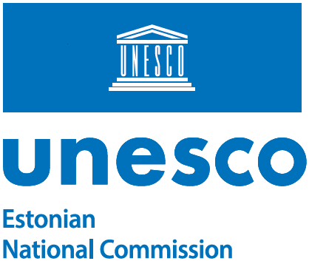
out

UNITWIN/UNESCO Chairs Programme
Division for Policies and Lifelong Learning Systems
Section for Higher Education
7, place de Fontenoy
F-75352 Paris 07 SP, France

 | 24.04.2026 | No 14-3/15-1

Support letter to Tallinn University to establish UNITWIN Network on Digital Transformation of Higher Education: Participatory Infrastructures for Inclusive Futures

Dear Madam/Sir,

The Estonian National Commission for UNESCO is pleased to express its support to the application of the Tallinn University to establish UNITWIN Network on Digital Transformation of Higher Education: Participatory Infrastructures for Inclusive Futures.

The Estonian National Commission for UNESCO has been engaged to the application’s consultation process by the potential UNITWIN network coordinator, Professor David Lamas, Head of Research Group and Head of Doctoral Programme, School of Digital Technologies of Tallinn University.

The proposed UNITWIN network directly advances UNESCO’s priorities in higher education by promoting equitable access to quality education, strengthening international scientific cooperation, and fostering ethical and inclusive digital transformation. The network contributes to the achievement of UN SDGs, promotion of Open Access, and AI ethics within UNESCO’s mandate. Anchored at Tallinn University and grounded in sustained partnerships in Europe, Africa, and Southeast Asia, the network addresses digital transformation as a systemic, research-informed process aligned with institutional practice and societal needs. Through integrated research, doctoral training, capacity building, and open knowledge sharing via participatory Democracy Labs, the network operationalises North–South–South cooperation and generates transferable knowledge to support sustainable, inclusive innovation in higher education systems.

We believe that the establishment of the UNITWIN network by the Tallinn University would further strengthen the UNITWIN programme in the field of digital transformation, higher education and participatory practice-based approaches, and it is our pleasure to support it.

Yours sincerely,

Kerli Gutman-Normak

Secretary-General

Additional recipients:
Prof David Lamas, Head of Research Group and Head of Doctoral Programme, School of Digital Technologies, Tallinn University

Madli Kumpas +372 6441431
Madli.Kumpas@kul.ee

